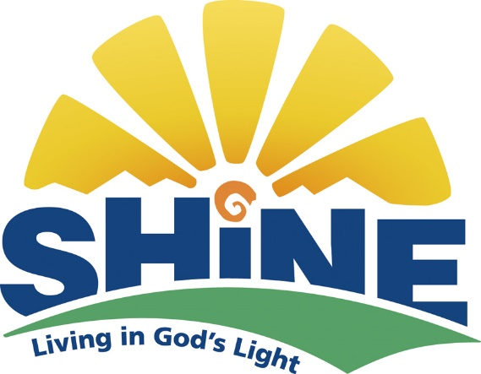
Rally Sunday
September 16, 2018
10:00-11:30 AM

Children Ages 3 Years old through Eighth Grade
Please join us for Sunday School
Followed by an Ice Cream Social for all ages.

Broad Brook Congregational Church
122 Main Street
Broad Brook, CT 06016
860-623-4547

Shine, Living in God’s Light is a Bible-based curriculum that teaches children about God's love through imagination, interactive biblical storytelling, spiritual practices, and service to the community. It takes children through important themes and characters in the Bible in 3 years.

Please RSVP to Linda York
Lyork76769@sbcglobal.net
860-623-4287

